Time: 80 minutes Total: 66 marks (+9)
ET (10% ~ 8 mins) ET (25% ~ 20 mins)
Show all your working, as answers without working may gain no credit. Calculators allowed.

1.
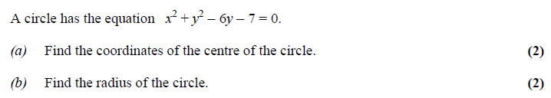
(Total 4 marks)
2.
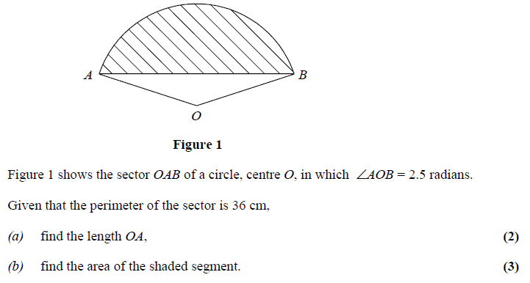

(Total 5 marks)
3.
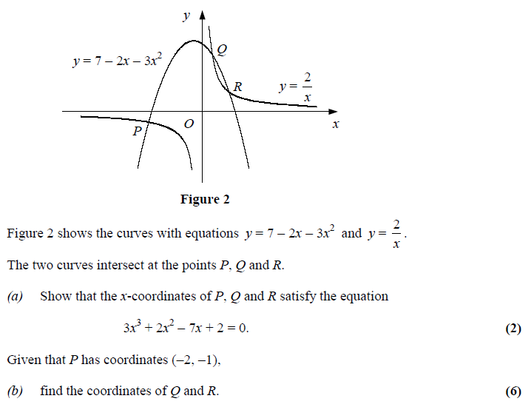
(Total 8 marks)
4.
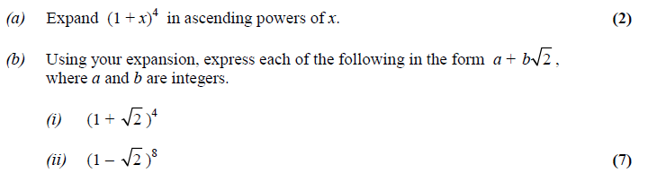
(Total 9 marks)
5. < at end of the paper, only attempt if you finish early and have time.>

6.
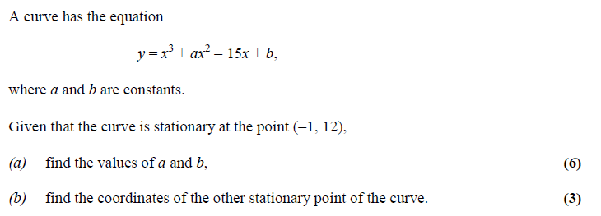

(Total 9 marks)
7.
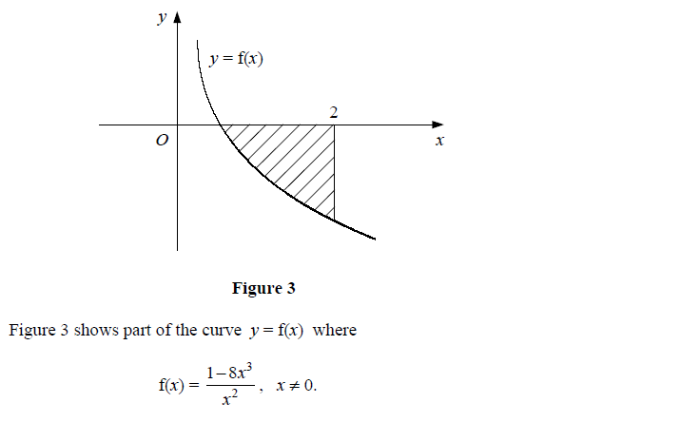
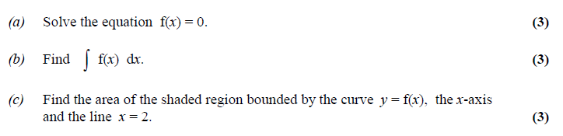
(Total 9 marks)
8.
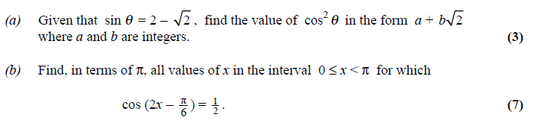

(Total 10 marks)
9.
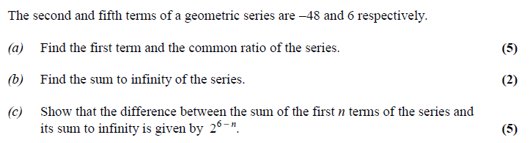

(Total 12 marks)

5. <ONLY IF YOU HAVE TIME>
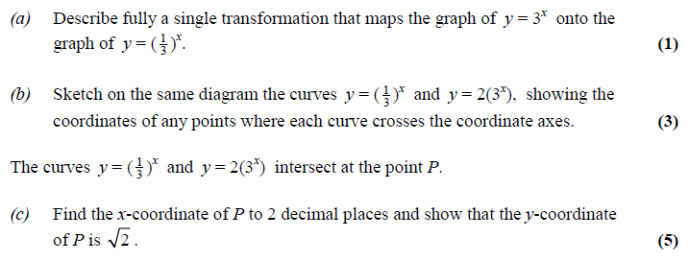
(Total 9 marks)

THE END

Marking Scheme –
This paper is a subset of the Solomon practice paper EC2sh_H / EC2sh_B
(Original Question numbers are prefixed with EC2sh_# Q# or similar)
Question # | 